***Available Products:***

* This section shows the **Available Products** table having two columns (**Name** and **List Price**). The products which are already added to the Order appear top of the list. Each products appears once in the list, that means there is no duplicate. (Please refer **Screen-1**)
* This section also keeps Add Products button which allows user to add product to the Order. (Please refer **Screen-2** and **Screen-3**)
* If the user wants to add the same product (which is already present to the Order), then the quantity will be increased by 1
* If the user wants to add the product which is not yet added, the product will be added having quantity count 1.
* Pagination is added for better user experience.

***Screen- 1:*** If we refer the below screen, we can see that four products has been added to the Order (under **Order Products** section) and those products appear top of the list under **Available Products** section.

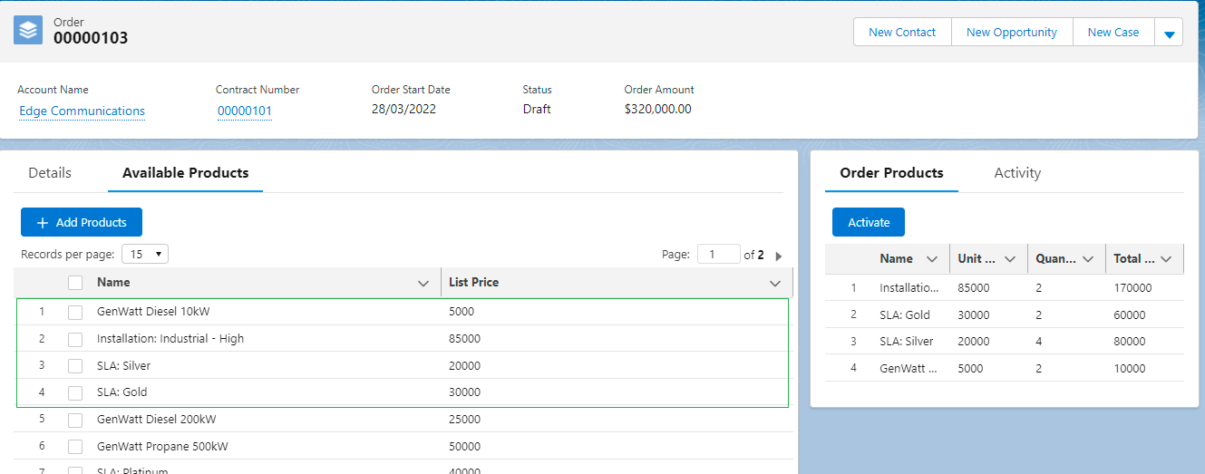

***Screen-2:*** User is adding **SLA-Gold** (which is already added to the Order) and **SLA-Platinum** (which is not yet added to the Order).

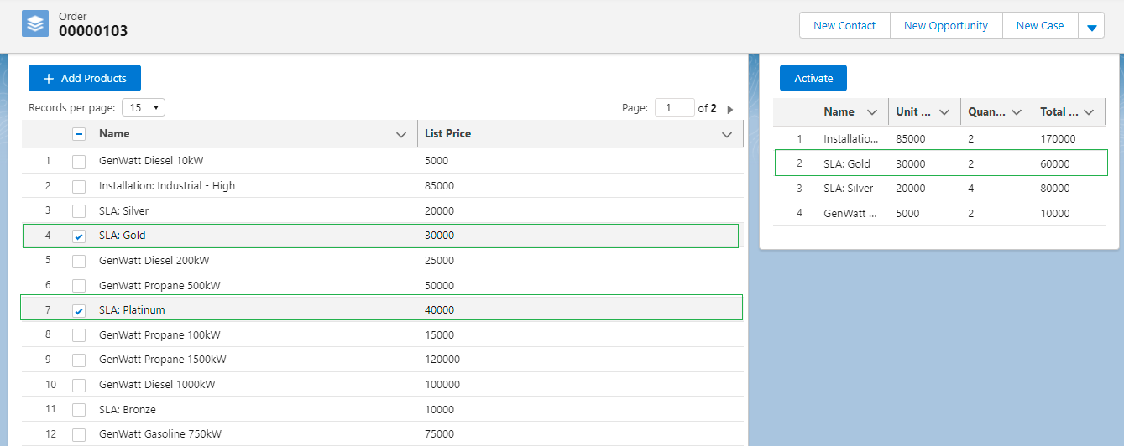

***Screen-3:*** After adding the above mentioned those two products, the **Order Products** table got refreshed with the new entries.

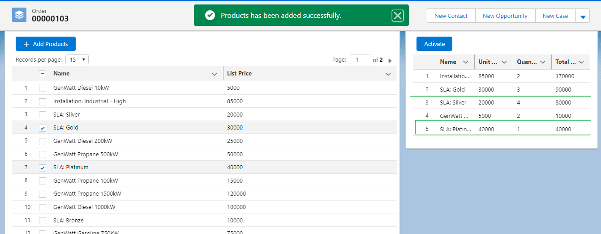

***Order Products:***

* This section shows the **Order Products** table having column Name, Unit Price, Quantity and Total Price. (Please refer **Screen-4**)
* When user adds any products (from the Available Product section), the Order Table will be refreshed accordingly (as mentioned above in Available Products section, please refer **Sreen-2** and **Screen-3**).
* This section also keeps **Activate** button. (Please refer below **Screen-4** and **Screen-5**)
* If user clicks on that, the status of that **Order** and related **Order Items** will set as **Activated.**
* Once the status becomes Activated, the user will not get the option to add any product or confirm the Order.

***Screen-4:*** Order Product Section (Order Product table and Activate button).

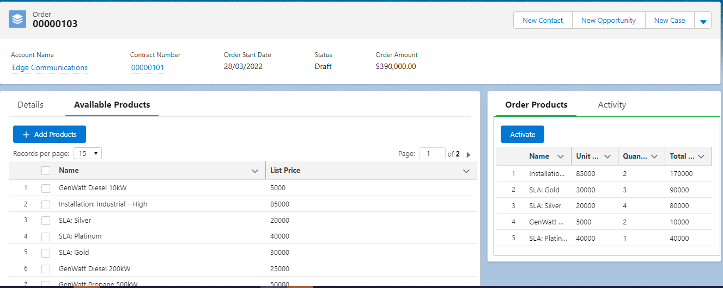

***Screen- 5:*** If the user clicks on Activate button. Then the page gets refreshed, and the status of Order and related Order Items are set as Activated. The user will not get **Activate** and **Add Product** on the screen.

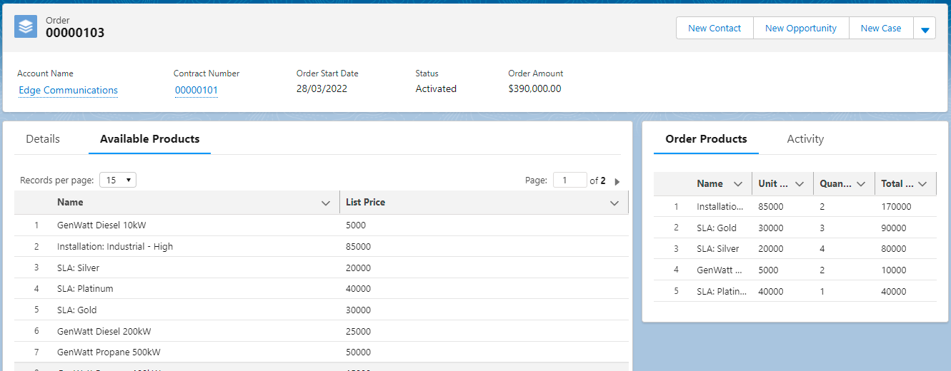

***Common Functionalities:***

* Both tables have soring option. User can do the sorting by their own choice.

***Note:***

* Once the user clicks on Activate button, the page got refreshed. So that Order Status will be reflected correctly. The user will not get the Activate as well as Add Product option..